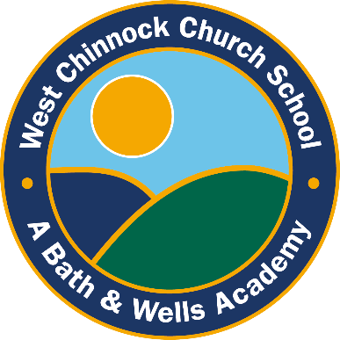

West Chinnock
Church School News
Friday 3rd July 2026
www.nortonandwestchinnockschools.co.uk/norton-school Tel: 01935 350232

Head’s Update…
Dear Parents and Carers,
I just wanted to say thank you for your patience and understanding last week with the red weather warning and school closure. These decisions are not taken lightly and understand the impact this can have on families. I am sorry I have not managed to be as visible in school due to currently working across and supporting several schools. Please do contact the office or staff if you need to speak to me at any point and I will get back to you straight away.
I am pleased to confirm that next year Mrs Callaghan will continue to teach Acorn class and Mrs Donovan-Lowe will continue to teach Oak class.
I would also like to share that Mrs de la Hey will be leaving us at the end of this term. She has been a valued and integral part of the team over her many years at the school. I know how highly she is thought of by all and will be greatly missed! I would like to thank Mrs de la Hey for all the amazing things she has done for our school! We will update you before the end of term regarding what this will look like in Acorn class in September.
Kind regards,
Kirsty Luffman
Head of School

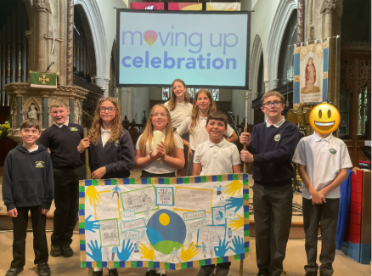
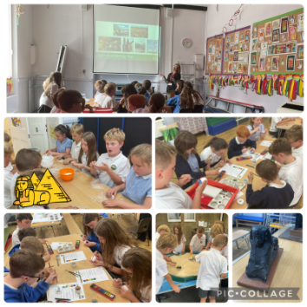



Our whole school attendance target is
95.5%
We are at
94.8%
Must Improve

Oak Class current attendance
94.2%

Must improve

!
Acorn Class current attendance
95.8%

WOW!!!



Head of school drop-in sessions
As I work between several schools, I am mindful that I am not always around for drop-in sessions. Please do contact the office if you would like to meet with me if I am not on site and I will get a meeting booked in as soon as possible.

Family Assembly Celebration
Every Friday at 9am
In the school hall

Congratulations to this week’s winners!

Headteacher’s Award

Fridays Children Award

Acorn Class
Acorn class have been making digital art in their computing lessons. They have been observing the artist Kandinsky and Matisse. In this lesson we were inspired by Matisse’s artwork titled ‘The Snail’.
We have also been learning about the Coastline in Geography. We have looked at how erosion is caused and building our own sea defences. We used blocks to recreate a ‘rip rap’ sea defence.

Oak Class
Oak Class enjoyed a fantastic Egyptian workshop led by Somerset Museum. Children rotated through exciting activities including bread making, an artefact dig and scarab beetle painting. They also handled real artefacts and discovered many fascinating facts about Ancient Egypt.
Year 6 represented our school wonderfully at the Moving Up Celebration in Taunton. They showcased a superb banner, which received many compliments, and were excellent ambassadors throughout this special event.

Our Year 5 and Year 6 pupils had a fantastic time on their Charterhouse residential! From the low ropes course and climbing wall to rocket building and launching, there was plenty of fun, adventure and teamwork. We were so impressed by everyone's resilience, encouragement and positive attitude throughout the trip. A huge well done to all the children—and we're pleased to report that Mrs D and Mrs Brimble are just about over the lack of sleep!

Carrymore Visit

Last week, Carymoor visited Acorn and Oak Classes, delivering two engaging workshops about recycling and the environment. Oak Class learned about electronic waste and its impact, enjoying an informative and interactive morning with Gary.

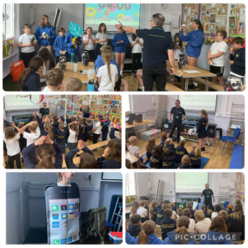

Diary Dates:

The school calendar for 2025 to 2026 can be found at www.nortonandwestchinnockschools.co.uk/key-information/term-dates.htm
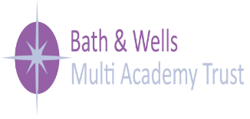

Vacancies


